Hi Team,
We strongly believe that every employee here at [Insert Company Name] is responsible for building and shaping the culture of our organization, not just management.
Therefore, starting on (date), we will be using TINYpulse, a cloud-based employee engagement platform.
TINYpulse will allow us to keep a pulse on our culture and how happy, frustrated, or burnt out employees are. Through TINYpulse you will be asked one or more employee engagement questions periodically, and your responses are completely anonymous.
You’ll also have the opportunity to recognize your peers by using Cheers for Peers, and at any time you can leave an anonymous Suggestion for leadership on how we can improve our culture or create a better work environment. Please remember to be professional and provide solution based ideas.
Please watch this quick video provided by TINYpulse, so you know what to expect. We encourage everyone to participate, so we can continue to build a great culture together.
What to expect?
- You will receive an email from TINYpulse when the survey goes live, an example will look similar to this (all communications will come from happiness@tinypulse.com):
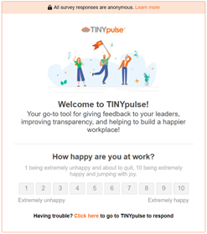
- Click the link to 1. Setup your password (required), 2. Answer your survey question(s)
- The main 3 parts to TINYpulse are:
1. Survey Question(s)
2. Cheers for Peers (sending recognition to your coworkers)
3. Suggestions (suggestion box)
Convenient ways to use or access TINYpulse:
iOS app & Android app, or Mobile Web Browser
Google Chrome Extension
Reach out if there are any questions! Looking forward to hearing from everyone! More follow-up and details to come!
[sender’s name]

